KEY STAGE 2 |  | KEY STAGE 3
Year 4 | Year 5 | Year 6 | Year 7
Place Value  Numbers beyond 1,000  Knowledge of negative numbers  Round to 10, 100, 1000  Order and compare -use the symbols  =, <, >, | Place value  Numbers to 1 million  1,000,000  Counting forwards and backwards with negative numbers and interpret  Round to the nearest: 100,000, 10,000, 1,000 100, 10  Order and compare- use the symbols  =, <, >, | Place Value  Numbers to 10,000,000  Calculate with negative numbers  Rounding with the addition of , to the nearest million  Order and compare- use the symbols  =, <, >, | Place value  Fluency between integers, fractions, decimals and percentages of any size  Order positive, negative integers, decimals and fractions  Rounding numbers to decimal places and significant figures  Order and compare the symbols =, ≠, <, >, ≤, ≥
Addition and subtraction  To add and subtract numbers up to 4 digits  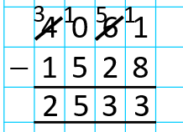  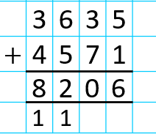 | Addition and subtraction  To add and subtract numbers with more than 4 digits  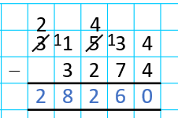  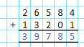 | Addition and subtraction  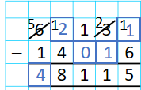  To add and subtract any numbers up to the nearest 10 million  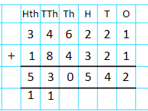  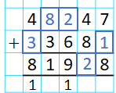  Application- missing numbers | Addition and subtraction  Application of methods applied to all forms of integers, decimals and fractions.  Understand the relationship and grow in fluidity
Multiplication  All Times tables up to 12 x 12- TESTING  Find factors of a number  Short multiplication: Multiply 3 x 1 digit numbers – formal column method  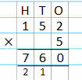 | Multiplication  Identify and find multiples and factors.  Know prime numbers- if a number is prime up to 100 and recall prime numbers up to 20.  Know a composite number is a non prime number  Recognise and use square and cubed numbers  Short multiplication: Multiply 4 x 1 digit numbers – formal column method  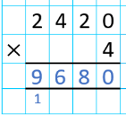  Long multiplication: Start with 2 digit x 2 digit- formal method Multiply up to 4 x 2 digit numbers- formal column method | Multiplication  Multiply 4 x 2 digits- formal column method  Identify common factors and multiples and prime numbers | Multiplication  Application of methods applied to all forms of integers, decimals and fractions.  Understand the relationship and grow in fluidity
Division  Make the link between division and multiplication facts up to 12 x 12  e.g.  64 ÷ 8 = 8  From the link 8 x 8 = 64  600 ÷ 3 = 200  From the link 2 x 3 =6  Non formal methods of division  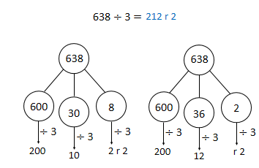 | Division  Divide numbers up to 4 digits by 1 digit number- short division ( Bus stop) and show remainders  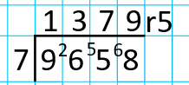  X and divide whole numbers and decimals by 10, 100, 1000 | Division  Divide numbers up to 4 digits by 2 digits- short division ( bus stop)  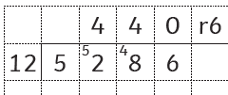 | Division  Application of methods applied to all forms of integers, decimals and fractions.  Understand the relationship and grow in fluidity
Problem solving  Single step  Written and mentally | Problem solving  Multi step  Written and mentally | Problem solving  Written and mentally  Order of operations: BIDMAS/BODMAS  Using all four operations | Problem solving  Written and mentally  Problem solving in any context  Order of operations: BIDMAS/BODMAS  Use conventional notation for the priority of the order of operations, brackets, powers and roots

